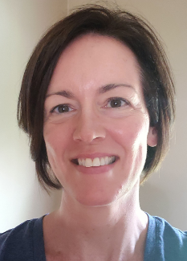

Patty Fong

Personal Information
- Mom of CJ, Beechwood Elementary 3rd grader
- Ft. Mitchell resident for 11 years; native of Cincinnati, OH
- Married to Jonathan Fong
- Member of Crossroads Church, Florence, KY

Relevant Professional Experience
- School Administrator, Cincinnati Public Schools 2017-present
  - Department of Student Services, English to Speakers of Other Languages (ESOL) Program Manager
- School Administrator, Lakota Local Schools
  - Elementary Curriculum Director
- Educational Consultant, Hamilton County Educational Service Center
- Elementary and High School ESOL Teacher (grades K-6 and 9-12)
- Elementary General Education Teacher (grades 1, 3, 4)

Beechwood Elementary Community Involvement
- Member of the Superintendent’s Advisory Council 2021-2022 school year
- Member of the Beechwood Elementary PTSA

Why choose me for the SBDM Council?

Beechwood is in a critical period of growth and change. I have a wide array of professional experience to help navigate through these changes so that we can maintain our status as one of the top school districts in Kentucky.

As an educator for 27 years and a mom of a Beechwood Elementary student with some mild special needs, I will bring a unique perspective to the SBDM team. I’ve worked in several large school districts that represent students from all backgrounds. I am well versed in all aspects of curriculum and the Multi-tiered System of Support (MTSS) that is essential for the academic growth of all students, including those who work below grade level expectations to those who consistently exceed them.

I consider myself a champion of public education and a voice for the underdog. I grew up in a working class community and was the first person in my family to attend college. With the support of a strong educational community, I’ve gone on to earn advanced degrees and have the career of my dreams. I want to ensure that every child, regardless of their background or origin, has those same opportunities.

My family and I value community service, so being part of Beechwood’s SBDM Council would be the perfect opportunity to blend my desire to serve with my talents and skills so that every Beechwood student has full access to every opportunity imaginable.

Friends and colleagues often describe me as a good listener, a compassionate leader, and solution-oriented. If elected to Beechwood’s SBDM Council, I will spend time listening and learning so that my contributions can help enhance some of the great things already happening at Beechwood while continuing to challenge us to grow and get better.

