Beechwood PTSA
2022-2023 Senior Scholarship Application
Applicant Name: ____________________________________________________
Address: ___________________________________________________________
Phone: _________________________ Email: _____________________________

School Information
I was accepted into the following school where I will be attending as a full-time student in the fall of 2023:
Name of Institution: _________________________________________________
Address: ___________________________________________________________

Student Commitment:
I have read and understand the requirements and guidelines pertaining to the Beechwood PTSA Scholarship Process. If awarded a scholarship, I know that the Beechwood PTSA will write a check to the institution listed above to be applied to my tuition. The Beechwood PTSA will mail this check to the bursar’s office at the institution. I will inform the Beechwood PTSA Board if: 1) I withdraw from above listed institution and do not enroll in another institution or change the institution where I plan to attend, 2) I change plans and do not attend any institution as a full-time student in the fall of 2023. I certify to the best of my ability that all information in this application is current and accurate.
____________________________________ _____________________
Signature of Applicant Date of Application

Parent or Guardian Statement: I have reviewed the application and to the best of my knowledge all information is current and accurate.

____________________________________ _____________________
Signature of Parent or Guardian Date

Beechwood PTSA
The Beechwood PTSA is awarding up to three $1,000.00 scholarships to Beechwood Seniors. After completion of the application and essay, please submit your entry to the high school office or e-mail it to the PTSA by Friday, May 12, 2023 at 11:59pm. Do not include your name on the actual essay. Late entries will not be accepted.
Email: beechwood.ptsa@beechwood.kyschools.us
or
Turn into the High School front office to be put in the PTSA mailbox
Scholarship Award winners will be announced at the Senior Honors Night on MAY XX 2023 and posted on PTSA’s social media.
***IF EMAILING please include essay as an attachment and do not include your name on the essay.

Note: The judges reviewing these essays will not know any information about who submitted the essay. They will only have a number listed on the essay and no name. The judges will pick the winners based on who best answers the essay question and will use a standard high school writing rubric to score the essays. Please make sure your essay has been thoroughly reviewed and edited before submitting it.

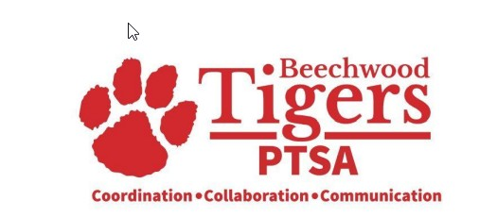

Beechwood PTSA

Scholarship Essay Prompt (500 words or less)

The Beechwood PTSA believes that our school is a unique and special place. How has your experience at Beechwood contributed to who you are as a person today?

** Please do not include your name on your essay pages *

